\section{Introduction}

. Mate-choice (i.e intersexual selection) can lead to captivating and highly complex traits, such as courtships or songs in birds *{danchin_ecologie_2005}. Nevertheless, many species do not exhibit such traits and the choice is based on much more discreet signs. “The most difficult and important act of choice is the choice of a mate” *{fisher_evolution_1915}, in this context any mistake can be very expensive since it impacts individual’s offspring. To avoid mistakes, many species have acquired the capacity to learn from the observation of others and can therefore use social learning in numerous decision-making processes.

Social learning can take different forms, as teaching or copying. The latter is simpler, and even exists in non-social invertebrates*{coolen_social_2005, laidre_mark_e._how_2010} . Many different behaviors can be copied *{thornton_alex_multi-generational_2010, van_leeuwen_group-specific_2014}. It’s particularly beneficial when individual learning is costly (time consuming or dangerous; see also*{webster_m.m_social_2008}) as in mate-choice. Therefore, copying the mate-choice of potentially more experienced conspecifics can be a good solution for naive individuals to avoid mistakes.

Mate-copying is a form of social learning in which the observation of a sexual interaction in conspecifics biases the subsequent mate-choice decision of the observer *{brown_fish_2011}. It has been first demonstrated in fishes *{dugatkin_lee_alan_reversal_1992}, followed by observations in many vertebrates *{galef_mate-choice_1998, yorzinski_same-sex_2010} and recently in invertebrates *{mery_public_2009, fowler-finn_complexities_2015}. Its benefits are double-sided, it allows naive individuals to avoid mistakes and make sure that their descendants will be preferred by conspecifics. Interestingly, in population with genetic preferences, mate-copying can override them *{dugatkin_interface_1996, witte_male_1998}. At a larger scale, mate-copying can even shape preferences of entire populations: a trait-based preference, transmitted vertically and horizontally and possibly for a long time can lead to long-lasting local tradition that can be considered as a form of animal culture*{brooks_importance_1998, danchin_cultural_2018}.

The existence of culture in non-human species has long been disputed *{laland_animals_2003} but is increasingly accepted among scientists *{aplin_experimentally_2015, whitehead_geneculture_2017}. The list of animals for which form of cultural transmission was documented is growing constantly *{van_schaik_orangutan_2003, thornton_alex_multi-generational_2010, whiten_culture_2017} , and one of the most recent may surprise many, Drosophila melanogaster *{danchin_cultural_2018}. Very few, if none, species have been studied as deeply, with as extensive knowledge in every scientific field (genetics, development, neuroscience…) as *Drosophila melanogaster*. Thus, existence of mate-copying in this species represents a wonderful opportunity to understand the obscure neuronal roots of an evolutive behavior broadly shared in the animal kingdom.

In drosophila, depending on the valence of the stimulus (either appetitive or aversive), different groups of neurons are involved in the learning process*{vogt_shared_2014,busto_olfactory_2010}. Therefore, our first step was to test whether mate-copying implies aversive or appetitive memory, by isolating different kinds of stimuli contained in copulation of conspecifics. We considered that a rejection represents an aversive stimulus and acceptance of copulation an appetitive stimulus for an observer female. So, we created two treatments by presenting to an observer, a male rejected by a female ("Rejection" treatment) or a male accepted by a female ("Acceptance" treatment), and we measured the observer’s inclination to copy.

In a second part, we went deeper into the neuronal mechanisms of mate-copying by searching which group of dopaminergic neurons is required for mate-copying. The neuronal mechanisms of non-social learning are very well known in drosophila (reviewed in #{cognigni_right_2018}). Regarding their roles in the latter, two brain structures are particularly prone to be involved in mate-copying, the central complex and the mushroom bodies. The central complex, localized in the center of the insect brain plays a major role in decoding visual information. It receives visual inputs from the rest of the brain and controls vision-related behaviors, memory and learning *{guo_vision_2017}. The mushroom bodies are an integrative center involved in learning, memory, decision-making and visual associative memory. Notably, specific groups of dopaminergic neurons localized in mushroom bodies are involved in the acquisition of aversive and appetitive visual memory *{liu_subset_2012, vogt_shared_2014}. On the contrary, despite a rich repertoire of well-studied social processes *{pasquaretta_how_2016, teseo_fighting_2016, dawson_social_2018}, neuronal mechanisms of social learning are still poorly understood. However, a recent study found that dopamine is required in mate-copying *{monier_dopamine_2018}. Dopamine is a neurotransmitter, that drives a variety of brain functions among which the formation of appetitive and aversive memory *{riemensperger_punishment_2005,sitaraman_serotonin_2008,alekseyenko_targeted_2010,berry_dopamine_2012,yamamoto_dopamine_2014}. Dopamine is produced in dopaminergic neurons, but we do not know which are involved in mate-copying. However, we do know some of the neurons required for non-social visual memory. #{vogt_shared_2014} showed that neurons labeled by TH-GAL4 and Ddc-GAL4 transgenes are essential in visual learning. Given that mate-copying involves visual learning, we expected these neurons to be required.

Thanks to Liu et al., we know that UAS-GAL4 technology can be used to block specific sets of neurons *{liu_subset_2012}. Precisely, by coupling UAS-GAL4 with the thermosensitive Shibire protein, it is possible to temporary silence specific groups of neurons by submitting flies to a restrictive temperature, and thus investigate whether they are essential for the studied process. Our goal was to use a similar technique to study mate-copying. We used mutant flies expressing GAL4 in TH-labeled or Ddc-labeled neurons, that we have silenced to see if those neurons are required in mate-copying (for more details, see "Fly strains and crossings" section). We thus created two treatments, depending on the group of neurons silenced, and measured mate-copying scores in each of them. If one group is involved in mate-copying, the corresponding treatment will not display mate-copying (score similar to random choice), due to the incapacity of mutants to learn.

\section{Material and Methods}

\subsection{Fly maintenance}

We used the common Canton-S strain of D.melanogaster (wild-type, and UAS / Gal4 lines described above). Flies were raised and kept in 30 ml tubes containing standard corn flour-yeast-agar medium at 25° ± 1°C and 56 ± 4 \% humidity with a 12:12H light:dark cycle. Humidity and temperature were controlled and adjusted continuously with two independents automatic humidifiers and one manual heater. Medium was cooked every 3 weeks and stored at 4°C until use. Flies were manipulated with a hand-made mouth aspirator made of a glass pipette, tubing and gauze.

Every morning, adult flies were removed from the breeding vials so that the newly emerged flies collected within the 6-8 hours were virgin. For Canton-S strain, 120 males and 120 females were used daily for breeding (20 tubes with 6 males and 6 females in each) and all other adults were euthanized in a freezer. For mutant strains, all adults were used for breeding.

Virgins were sexed without anesthesia, by gentle aspiration and then kept in unisex groups of 7 females or 14 males until experiments. Both demonstrator and observer flies were 3 or 4 days old. Males and females were used only once as females are reluctant to re-mate *{chapman_sex_2003} and reject males they just saw copulating *{loyau_when_2012}. After experiments, all flies were put in a food vial and cold-euthanized at the end of the day.

\subsection{Fly stains and crossings}

For the second experiment, we used two mutant genotypes, Ddc-GAL4/w+;;UAS-Shits/+ and w+/w-;;UAS-Shits/TH-GAL4 ,obtained by crossing homozygous lines.

UAS-Shits is a transgene that contains an GAL4-specific enhancer,UAS (Upstream Activating Sequence) driving the production of Shibire protein in cells where GAL4 is present. Shibire is a thermosensitive protein that inhibit neuronal activity at restrictive temperature (30°C) by preventing vesicle recycling *{kitamoto_conditional_2001}. Ddc-GAL4 and TH-GAL4 drive production of a transcriptional activator (GAL4) only in specific subsets of dopaminergic neurons. GAL4 activates the expression of genes downstream to UAS. Ddc-GAL4 labels neurons involved in appetitive olfactory memory:the blockade of these neurons by Shibire protein has been shown to impair the acquisition of such memory at restrictive temperature.TH-GAL4 labels neurons involved in aversive olfactory memory *{liu_subset_2012}.

As white recessive mutation w- impairs fly vision *{gotz_optomotorische_1964}, we used mutant females with one wild-type copy of the white gene for the experiments. To do so, we crossed w+;;Shits males with females from each Gal4 line. To obtain w+;;Shits strain from a w-;;Shits strain, we crossed males w-;;Shits with females w+;;TM2/TM6b over two generations and selected TM2 non TM6B flies only, with CO2 anesthesia, and we then isolated homozygous w+;;Shits progeny.

TH-GAL4 and Ddc-GAL4 lines were provided by Guillaume Isabel in the same Canton-S background as the Wild-type strain.

\section{General experimental procedures}

Artificial male phenotypes were created by dusting virgin males with pink or green powder *{mery_public_2009}. Each vial of males was randomly assigned to a color. Before the experiment started, males were placed in a clean vial to remove the excess of dust for at least 20-30 min. Experiments took place in the same tube set-up and a similar but slightly modified speed-learning protocol than described in #{dagaeff_drosophila_2016} (Figure 1, see also specific experiment section).

Demonstrator and observer flies were placed in two compartments of double plastic tubes, separated by a thin glass partition and closed by cotton plugs. All replicates were run in blocks of six trials with cardboard barriers between experimental set-ups, to prevent information exchange between the flies and disturbance from the surroundings.

During the demonstration, we always showed two different male phenotypes (color) to the observer females, with one favorite that copulated with the demonstrator female. If demonstrator females refused to copulate, the trial was discarded. Specifics of demonstrations for each experiment are described above (see specific experiment section).

Once the demonstrations were over, we started the mate-copying test by introducing a couple of colored virgin males (one of each color) in front of the observer female and we removed the partition, allowing the female to freely choose between males for 30 min. The partition was put back in place when all three flies were in the same side of the tubes, to promote proximity between flies. During that time, we recorded the time of first courtship for each male, the time when copulation started and the color of the chosen male. The onset of the courtship was defined as the first wing-extension of a male (Figure 2).

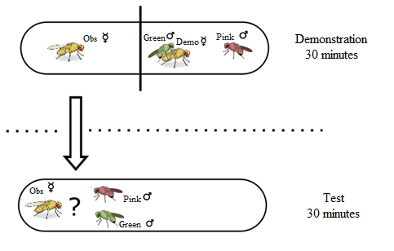\begin{figure}

Figure 1

All experimental flies were virgin. During demonstration, observer female observes the free choice of demonstrator female. Observer females are tested immediately after the end of the demonstration. After all copulations ended, demonstrators were removed.

\centering

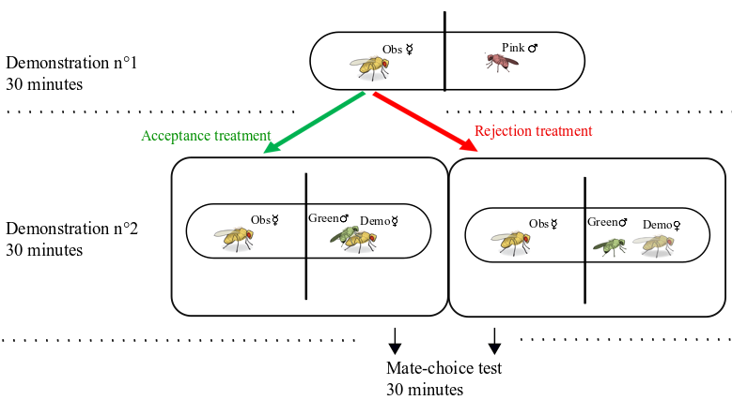

\includegraphics[width=0.8\textwidth]{images/classic}

\caption{Légende ici.}

\label{fig:Classic protocol}

\end{figure}

\subsection{Acceptance/Rejection experiment}

During this first experiment, we tested whether mate-copying is achieved through aversive or appetitive memory. To do so, we split the negative and positive information given by the usual mate-copying demonstration. A classical demonstration, in which a demonstrator female chooses between two males, contains a rejection (negative information) of a male and an acceptance (positive information) of the other one. We thus created three demonstration treatments: (1) a control where a demonstrator female freely chooses between two males, (2) an “acceptance” treatment with one accepted male copulating with a demonstrator female, and (3) a rejection treatment with one male actively rejected by a female (Figure 3).

\subsection{Neuronal blockade experiment}

This second experiment aimed at exploring the mechanisms underlying the results of the Acceptance/Rejection experiment by discovering one group of dopaminergic neurons involved in mate-copying.

The demonstration was similar to classical protocol (Figure 1), but we used Ddc-GAL4/w+;;UAS-Shits/+ (treatment “Ddc”) and w+/w-;;UAS-Shits/TH-GAL4 mutants (treatment “Gal4”) as observer females. The use of these mutants allowed us to have a temporal control on specific sets of neurons presumably involved in appetitive (Ddc) or aversive (TH) memory, thanks to the thermosensitive activation of Shibire. During the demonstration and 30 minutes before, observer mutant females were heated to a restrictive temperature of 33°C, thanks to a heating mat under the tube of these females. At 33°C, Shibire protein blocks the neurons in which it is expressed, and thus the acquisition of appetitive memory should be blocked in observer females of “Ddc” treatment, and the acquisition of aversive memory in “TH” females.

After all copulations ended, demonstrator males and females were removed. Observer females were then stored individually in clean tubes at 25°C for 3-4 hours to ensure that labelled neurons are no more blocked, then we proceeded to a classical test at 25°C.

\begin{figure}

\centering

\includegraphics[width=0.8\textwidth]{images/ar}

\caption{Légende ici.}

\label{fig:ar}

\end{figure}

\subsection{Mate-copying score}

As in previous studies *{danchin_cultural_2018,nobel_mate-copying_2018,monier_dopamine_2018}, a mate-copying score evaluated female’s tendency to copy the choice of the demonstrator. A mate-copying score of 1 was assigned to females that copulated with the color preferred by demonstrator females and a score of 0 in the opposite case. For each treatment, a mate-copying index was calculated as the mean of mate-copying scores per treatment, a random choice indicated by a value of 0.5. All replicates where only one male courted the female before copulation were discarded because in these situations the female was not unambiguously in a position to make a choice between the two colors.

\subsection{Statistical analyses}

All statistical analyses were performed with the R software version 3.5.1 (R Core Team, 2018).

For each treatment, the difference from a random choice was tested with a binomial test. Mate-copying scores were then analyzed in a generalized linear mixed model (GLMM, package lme4 *{bates_fitting_2015}). Starting models contained the following fixed effects: treatment, normalized air pressure (air pressure in Toulouse-Blagnac weather station, at the time of the beginning of the experiment, minus mean air pressure), normalized air pressure variation within the six preceding hours and all interaction between these three variables, experimenter effect and its interaction with treatment. A random “block” effect was also introduced in the models to account for the non-independence of observer flies from the same block of 6 tubes-set up trained and tested in parallel. The significance of fixed effects was tested using Wald chi-square tests included in ANOVA function (car package, #{fox_r_2018} ). Model simplification was achieved by successive withdrawal of the non-significant terms in a backward selection approach, using P-values and starting with the highest-order interaction. The final model was chosen as the one with the lowest Akaike Information Criteria (AIC, Akaike, 1969). Comparisons between treatments were done using post-hoc X² tests.

\subsection{Ethical statements}

Behavioral observations of D. melanogaster required no ethical approval and complied with French laws regarding animal welfare. We kept the number of flies used in this study as small as possible. We handled flies by gentle aspiration without anesthesia to minimize damage and discomfort. After the experiments, individuals were euthanized in a freezer at -20°C.

\section{Results}

\subsection{A/R Experiment}

\label{subsec:AR-experiment}

In total, we tested 850 females among which 530 copulated, including 192 with double-courtship, 64 for each treatment. First we tested for female's color preference with binomial test but neither in the demonstration (N = 850, 426 females copulated with green males and 424 copulated with pink males; binomial test: P = 0.973) nor the test (N = 192, 90 copulated with pink and 102 with green males; binomial test: P = 0.427) was there any significant difference between the two colors.

For each treatment, the difference from random choice was tested with a binomial test, acceptance (where the observer female sees a copulation, N = 64, P {\textless} 0.001) and control (N = 64, P = 0.03) were both significantly different from random, but rejection treatment (where the observer female sees a male rejected without copulation, N = 64, P = 0.382) was not (Figure 4).

To test for the significance of mate copying among treatments, we built a global model including the effects of experimenter, treatment, normalized air pressure (actual air pressure minus global mean of air pressure), normalized air pressure variation (for the last six hours) and the interaction between air pressure and variation of air pressure. Only the treatment had a significant effect on mate-copying (GLMM, $\chi^2$: $N = 192$, $\chi^2 = 10.447$, $p = 0.005$), air pressure (GLMM, $\chi $²: N = 192, $\chi $² = 0.572, P = 0.449) and variation of air pressure (GLMM $\chi $²: N = 192, $\chi $² = 1.831, P = 0.176) were non-significant. The interaction between air pressure and variation of air pressure was close to be significant (GLMM $\chi $²: N = 192, $\chi $² = 2.946, P = 0.086), as we could have expected in regard of the results of #{dagaeff_drosophila_2016}. No significant difference has been found between control and acceptance treatments ($\chi $² = 1.76, P = 0.18; Fig4), but both are different from rejection treatment (acceptance - rejection: $\chi $² = 11.62, P {\textless} 0.005; control - rejection: $\chi $² = 4.52, P = 0.033; Fig4).

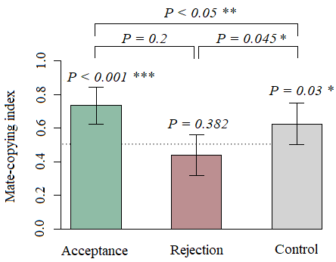

Voir Figure~(\ref{fig:mcsar}).

<<<<<<< HEAD

=======

% \begin{figure}

% \centering

% \includegraphics[width=0.8\textwidth]{images/histogramme-mcs}

% \caption{Légende ici.}

% \label{fig:histogramme-mcs}

% \end{figure}

>>>>>>> master

\begin{figure}

\centering

\includegraphics[width=0.8\textwidth]{images/mcsar}

\caption{Légende ici.}

\label{fig:mcsar}

\end{figure}

\clearpage

\newrefcontext[sorting=nyt] % sorts the bibliography by name first, then year, title

\printbibliography

\end{document}